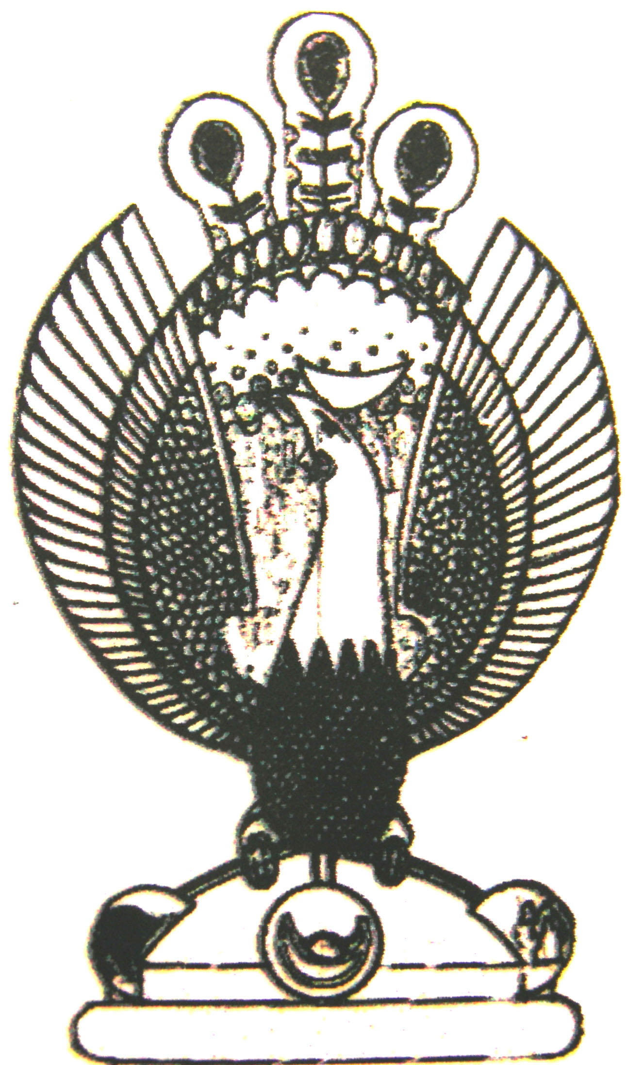

THE HERITAGE

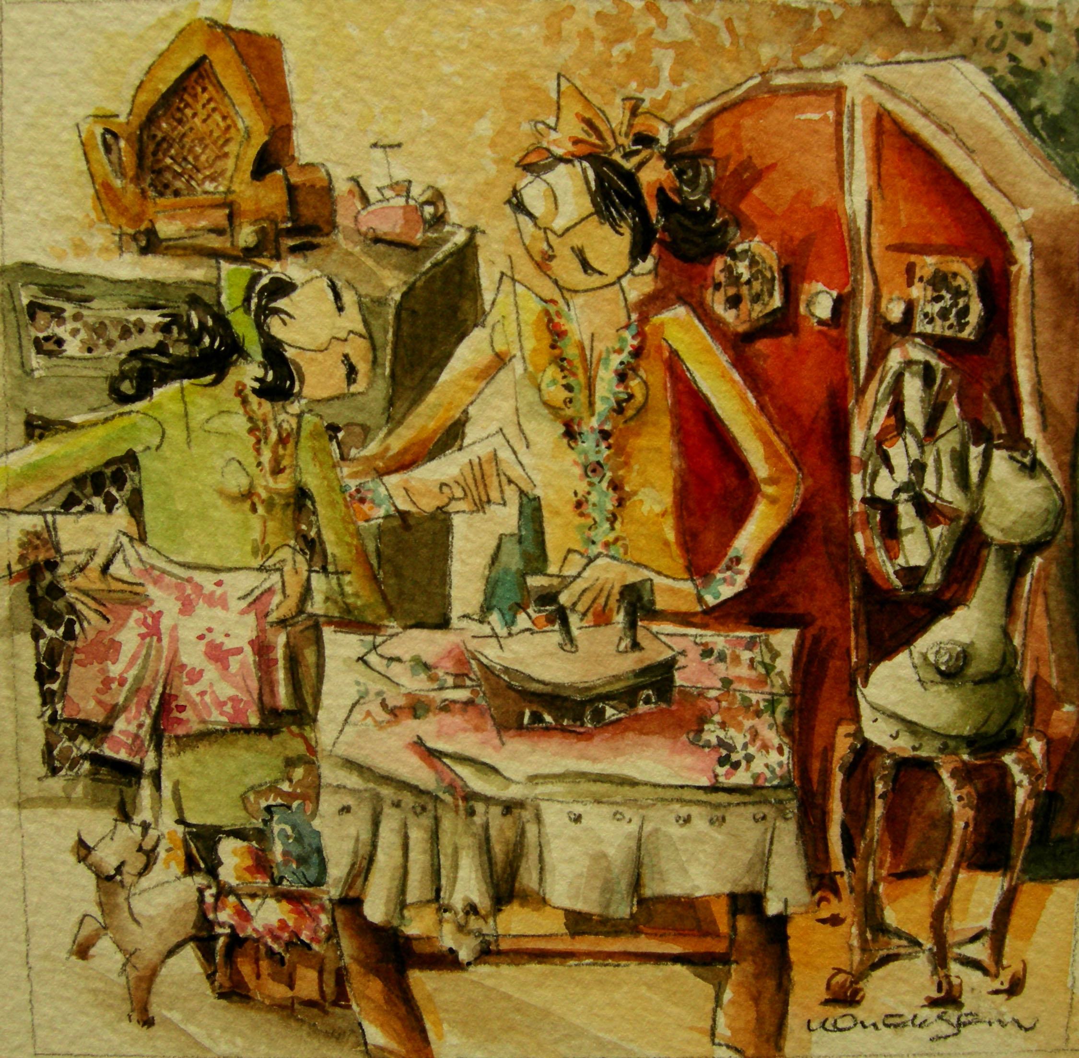
Seterika
In more conservative homes school was out of the question for girls once they reach 12. They would engage a female tutor to teach their daughter house management including ironing clothes with an iron containing burning coal.

